# Accounting In Business

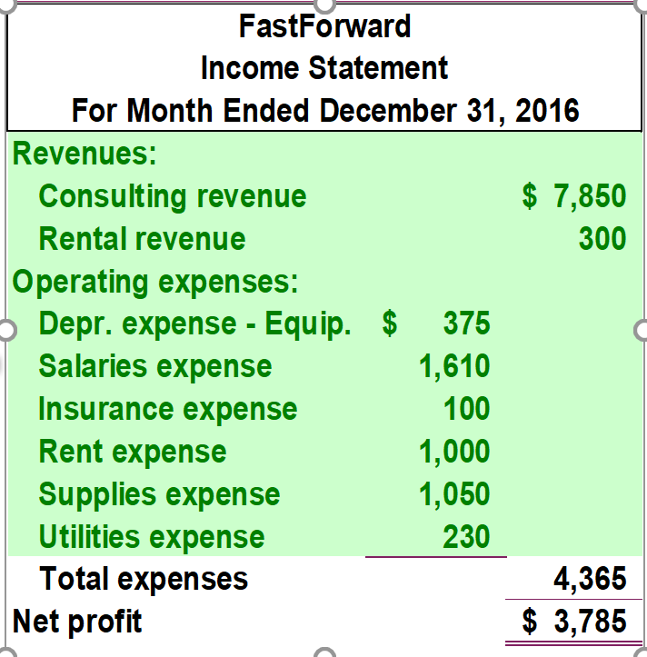Principles of accounting

* Revenue recognition principle, cost principle (objective cost = how much was paid for it), matching principle, full disclosure principle

Assumptions

* Going-concern assumption (business will continue), monetary unit assumption (ignore inflation), business entity assumption, time period assumption

Conceptual framework: 6 characteristics

* Relevance, faithful representation, comparability, verifiability, timeliness, understandability

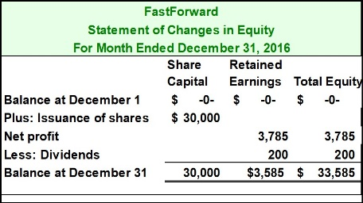Accounting equation

* Assets (Cash, PPE, receivables) = Liabilities (payables) + Equity (share capital + revenue – expenses – dividend)

Financial statements

* Income statement (Revenue – Expenses = Profit)
* 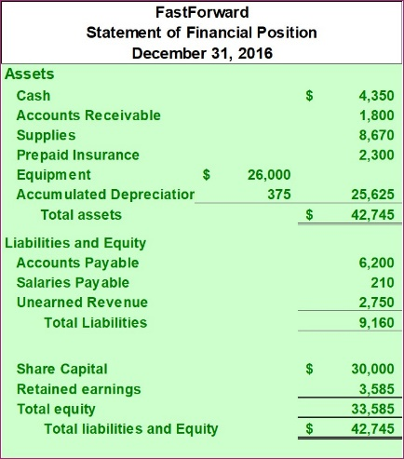Statement of Changes in Equity (Initial balance = issuance of shares + net profit – dividend = final balance)
* Statement of financial position/balance sheet (total assets = total liabilities + equity)
* Statement of cash flows (cash flows from operating activities, investing activities and financing activities)

# Recording Transactions

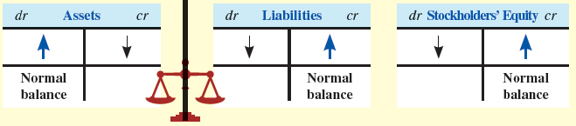

|  |  |  |  |
| --- | --- | --- | --- |
| Journal Entries | | | |
| Date | Account title | Debit | Credit |
| Aug 29 | Software  Accounts Payable | 9,000 | 9,000 |

|  |  |  |  |
| --- | --- | --- | --- |
| Account Ledgers | | | |
| Accounts Payable | | | |
| Jul 31 | 1,000 | 1,500  9,000 | Aug 29 |
|  | | 9,500 | end bal |

|  |  |  |
| --- | --- | --- |
| Company Name  Trial Balance  At Dec 31, 2015 | | |
|  | Debit | Credit |
| Assets | x |  |
| Liabilities |  | x |
| Equities (share cap + retained earnings + dividends) |  | x |
| Revenues |  | X |
| Expenses | x |  |
| Totals | 100 | 100 |

# Adjusting Accounts

Why: Revenue and expense recognition principles

Adjusting entries

* Deferred expenses/revenues (Cash before expense or revenue)
  + Once expense is incurred, down assets (prepaid rent), up expense (rent expense)
  + Once revenue is incurred, down liability (unearned revenue), up revenue
* Accrued expense/revenue (Cash after expense/revenue)
  + Once cash is paid, up expense, up liabilities
  + Once cash is received, down assets (receivables), up revenue

Depreciation expense

* Straight line depreciation =
* Contra-asset account “Accumulated Depreciation” to offset asset account

# Closing Accounts

Reset revenue, expense and dividend account balances to zero at the end of a period

* Retained earnings account (temporary account)
* Steps: close credit balances in revenue accounts to income summary, close debit balances in expense accounts to I Summary, close income summary to RE, close dividend accounts to RE
* Post-closing trial balance only has permanent accounts. Total debit must = total credit.

|  |  |  |  |  |
| --- | --- | --- | --- | --- |
|  |  | Dr | | Cr |
| Dec 31 | Consulting revenue  Income summary | 7,850 | | 7,850 |
| Dec 31 | Income summary  Depreciation expense  Salaries expense | 2,000 | | 390  1,610 |
| Dec 31 | Income summary  Retained earnings | 5,850  Note: 3785 = Net profit | | 5,850 |
| Dec 31 | Retained earnings  Dividends | 200  Note: profit and dividend in statement of changes in equity | 200 |

* Statement of changes in equity computes retained earnings
* Statement of financial position (A = L + E) includes the updated retained earnings

# Cash and Internal Controls

Important principles and guidelines

* Insure assets, bond key employees
* Separate recordkeeping from assets custody
* Divide responsibility in related transactions
* Cost of internal control must not exceed their benefits
* Cash receipts promptly deposited in a bank
* Cash disbursements made by cheque

Cash and cash equivalents include:

* Liquid assets = able to pay for short-term obligations
* Cash, cheques, money orders
* Short-term highly liquid investments

Restricted cash

* Cash set aside for a purpose, expected to be used up within a year

Cash sales

* “Cash over and short” account: for miscellaneous revenue or expense incurred during payments from customers during over-the-counter cash receipts

Cash disbursements (petty cash system)

* All expenditures made by cheque, except for really small amounts
* Cash removed from general bank account to hold at its premises in a locked cash box; petty cash custodian is responsible for operating the petty cash fund.
* 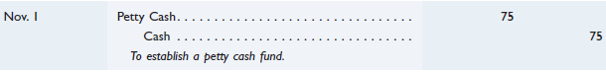
* 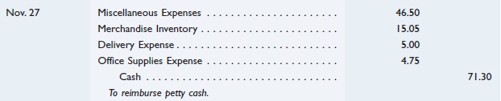
* Float: an amount of money where total cash + total receipts in box = float amount

Bank controls

* Restricted access to cash, documented procedures, independent verification
* Provides a bank statement. Bank reconciliations are prepared to verify accuracy of bank statement and cash account of company

Bank reconciliation

|  |  |
| --- | --- |
| **Bank balance** | **Book balance** |
| + deposits in transits | + collections and interest (collections not yet recorded) |
| - outstanding checks | - uncollectibles (NSF checks + service fees + service charges) |
| +/- errors | +/- errors |
| = adjusted cash balance | |

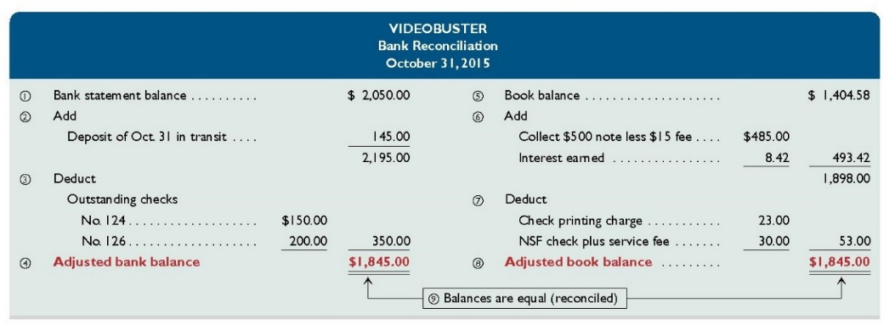

# Receivables

Accounts receivables

* Amounts from customers for credit sales
* Advantages of credit sales: Credit standing knowledge from 3rd party (card company), risk of giving credit is transferred to credit card issuer, cash collections are quicker via credit, variety of credit options increases sales volume
* Disadvantage of credit sales: credit card company charges a fee

|  |  |  |  |
| --- | --- | --- | --- |
| July 15 | Cash  Credit Card expense  Sales revenue | 96  4 | 100 |

Allowance method (to account for bad debts)

* Contra-asset account: “Allowance for doubtful accounts”, Expense account: “Bad debt expense”
* Allowance for doubtful accounts = estimated bad debt, based on experience
* So that write offs do not affect the realisable value of accounts receivable (also to match expense to sale)
* For a guy who had a bad debt initially, but then pays the debt written off after

|  |  |  |  |
| --- | --- | --- | --- |
| Dec 31 | Bad Debts Expense  Allowance for Doubtful Accs | 1,500 | 1,500 |
| Mar 23 | Allowance for Doubtful Accs  Accounts Receivable – J.C. | 520 | 520 |
| Apr 11 | Accounts Receivable – J.C.  Allowance for Doubtful Accs  Cash  Accounts Receivable – J.C. | 520  520 | 520  520 |

Methods of estimating bad debts

* Percentage of credit sales
* Percentage of receivables (more accurate)
  + Estimate = year-end accounts receivable x bad debt percentage
* Aging of receivables
  + The more overdue and older an account, the less likely it is to be collectible. Group receivables by age, then multiply by bad debt estimate for each group

Notes receivable

* Interest = principal x annual interest rate x
* Dishonoured notes: notes receivable and interest revenue 🡪 accounts receivable

# Inventories

Inventory

* All goods a company *owns* and *holds for sale*, regardless of where the goods are
* Goods in transit
* FOB shipping point = sale occurs/ownership transfers at seller’s shipping dock
  + Buyer takes responsibility for transporting the goods (freight-in cost)
* FOB destination = sale occurs/ownership transfers at destination
  + Seller responsible for transporting the goods (delivery expense)
* Goods on consignment
  + Consignee sells goods for owner (consigner), but goods belong to consigner
* Damaged or obsolete goods
  + Not counted in inventory if they cannot be sold
  + If can be sold at reduced price, included in inventory at net realisable value (selling price)
  + (Gross realisable value= net realisable value + sales allowances + discounts + returns)
  + Loss in value reported when damage is incurred

Inventory cost (cost of items)

* Costs of expenditure necessary to bring an item to a saleable condition and location
* Shipping, import duties, invoice cost, incidental costs, insurance, packaging (not including storage cost)

Inventory accounting system

* Perpetual inventory system
  + Inventory account is continually updated to reflect purchases and sales, records are always up to date
  + Mostly for expensive/branded goods
* Periodic inventory system
  + Inventory account updated at year-end
  + Only the amount of purchases and amount of sales recorded (not indiv item basis)

Inventory costing methods

* Specific identification
  + No assumptions
  + Each item is identified with a specific purchase and invoice, has its own specific cost
* First in first out (FIFO)
  + Assumes cost flows in the order incurred
  + Cost of earliest units acquired are charged to the latest COGS

|  |  |  |  |  |
| --- | --- | --- | --- | --- |
|  | Purchases | COGS | Ending inventory balance | |
| 1 Jan | 2 units @ 35 |  | 2 units @ 35 | 70 |
| 1 Feb | 3 units @ 40 |  | 2 units @ 35  3 units @ 40 | 190 |
| 1 Mar |  | 2 unit @ 35  1 unit @ 40 | 2 units @ 40 | 80 |

* Weighted average (WA)

|  |  |  |  |  |  |
| --- | --- | --- | --- | --- | --- |
|  | Purchases | COGS | Ending inventory balance | | WAC |
| 1 Jan | 2 units @ 35 |  | 2 units @ 35 | 70 |  |
| 1 Feb | 3 units @ 40 |  | 2 units @ 35  3 units @ 40 | 190 | 190/5 = 38 |
| 1 Mar |  | 3 units @ 38 | 3 units @ 38 | 114 |  |

* All costing methods are acceptable but must be disclosed
* If purchasing costs regularly rise, then
  + FIFO: higher profit, WA: lower profit and higher COGS
  + Lower profit = lower taxes, but higher profit = investor confidence

Value of merchandise inventory: lower of cost and net realisable value (NRV)

* Merchandise inventory has to be reported at the lower of its cost or its NRV
  + Prevents costs of inventories or assets from being overstated
* NRV = estimated selling price - estimated cost of completion - estimated costs necessary to make the sale
  + If recorded cost > NRV, loss of value of inventory
  + If decline in NRV, loss of value of inventory

Inventory relation

* COGS = beginning inventory + net purchases (company) - ending inventory
* Understating ending inventory 🡪 overstated COGS, understated beginning inventory the following year, hence COGS will be understated, profit overstated

# Non-Current Assets

Cost of PPE

* PPE recorded at cost when acquired
  + Inclusive of all costs *normal* and *necessary* to get the asset in place and ready for use
  + Unexpected repair costs/other costs like traffic fines not included: not normal
* Land
  + Includes things that permanently add to land’s value (not fences, shrubs, etc)
* Buildings
  + When constructing a building for use, cost includes materials, labour, etc
* When there is a lump-sum purchase, allocated cost based on relative market value, estimated by appraisal or by tax-valued valuations of the assets
  + Eg for a lump-sum purchase of $90,000,

|  |  |  |  |
| --- | --- | --- | --- |
|  | Appraised Value | Percent of Total | Apportioned Cost |
| Land | $30,000 | 30% | $27,000 |
| Building | 70,000 | 70 | 63,000 |
| Total | 100,000 | 100% | $90,000 |

Depreciation of PPE

|  |  |  |  |
| --- | --- | --- | --- |
| Dec 31 | Depreciation expense  Accumulated depreciation | 1,000 | 1,000 |

* Measured only when asset is in use
* Factors
  + Cost, Residual value
  + Useful life
    - Variables: Wear and tear, inadequacy, obsolescence
    - Variables are difficult to predict because of changes in demand, new inventions, improvements; assets usually disposed of before it wears out
    - Useful life prediction based on experience or engineering studies
* Methods of calculation
  + - Straight line depreciation method
      * Depreciation expense per year =
    - Units of production method
      * Charges a varying amount of expense each period depending on usage
      * Depreciation per unit of production =
      * Depreciation expense = depreciation per unit units produced in period
    - Double declining balance (DDB) method
      * Larger depreciation expense in early years, less in later years
      * Uses a multiple of 2 of the straight line rate, applied to asset’s beginning of period carrying amount
* Goal: postpone tax payments; company will want higher expense, less taxable profits
* Partial-year depreciation applies
* Changes in depreciation estimates
  + Revise expense computation by spreading cost over the remaining useful life, and for the rest of the time new estimate is used

Impairment of PPE

* Impaired: when asset’s NBV (net book value) > recoverable cost
  + NBV = equipment value per balance sheet – accumulated depreciation
  + Recoverable cost = higher of ‘net amount from selling the asset’ and ‘value from continuing its usage’
  + Reasons for impairment: physical damage to machine, obsolescence, fall in demand for the finished goods
  + PPE’s carrying amount written down to recoverable amount
    - Debit ‘impairment loss’ (expense), credit ‘accumulated impairment loss’ (contra-asset) (can be combined with accumulated depreciation)

Discarding/selling of PPE

* Accumulated depreciation = x
* NBV = B/S value - x
* Loss on disposal = disposal/selling price - NBV
* Dr accumulated depreciation (close contra asset acc), dr loss on disposal (expense)(or cr gain on disposal), cr asset account

Intangible assets

* Lack physical substance; asset embodies future economic benefits
* Internal intangibles (eg brands, research costs): expensed when incurred
* External intangibles (eg patents, licence, copyrights): expensed upon annual amortised (depreciation for intangible assets) or when impaired
* For intangibles with definite life-span: amortise, test for impairment only if indications show
  + Amortisation expense per year calculated like depreciation expense
* With indefinite life-span (eg goodwill): don’t amortise; test for impairment annually
  + Goodwill: the price paid for a business, minus the market value of its net assets (A-L)

Revaluation of PPE

* Cost model
  + Carrying amount = cost – accumulated depreciation and impairment
* Revaluation model
  + Carrying amount = fair value at last revaluation date – accumulated depreciation and impairment

# Current Liabilities

Definition: past event 🡪 present obligation 🡪 expected future payment

Classification

* Current liabilities
  + Short term obligations, paid within current operating cycle/year
  + Includes: refundable deposits, GST payable (to authorities), employee’s CPF payable
  + Current portion of long-term debt: a fraction that must be repaid within a year; reclassify long-term debt as current liability
* Long-term liabilities
  + Due >1 year after

Provisions

* A liability of uncertain timing or amount, but can be estimated
* Warranty provisions
  + Estimated in each period, provision account
  + Dr “warranty expense”, cr “provision for warranty expense”
  + When claimed: Dr “Provision for warranty claims”, Cr cash

Contingent liabilities

* A possible obligation, not clearly evident, arising from a past event, only certain in the future (eg lawsuit losses, financial support from other companies)
* If probable: estimate reliably, make a provision (‘estimated liability for loss’)
* If possible: disclose in notes, do not record
* If remote: no record
* More conservative treatments for contingent assets
  + If future receipt is probable, disclose in notes. Otherwise, don’t record.

# Shareholders’ Equity

Types of shares

* Ordinary shares
  + Ordinary shareholder = owner, rights: voting, profits via dividends, in event of liquidation will share in company’s assets
* Preference shares
  + Priority in dividends and claims in a liquidation, but no voting rights
  + Advantage: raises capital without diluting control

Issuing ordinary shares

* For cash
  + For example, if 20,000 shares are issued for $0.20 each, journal entry:

|  |  |  |  |
| --- | --- | --- | --- |
| 1 Sep 16 | Cash (20,000 x $0.20) | 4,000 |  |
|  | Share Capital – Ordinary |  | 4,000 |

* For assets other than cash (eg land, legal services)
  + Amount should be recorded at fair value of asset/service, or if that cannot be estimated, record at fair value of shares issued eg

|  |  |  |  |
| --- | --- | --- | --- |
| 1 Sep 16 | Land | 4,000 |  |
|  | Share Capital – Ordinary |  | 4,000 |

* In B/S, listing of accounts:
  + Preference shares, ordinary shares, capital reserves, then retained earnings

Measuring share value

* Fair value: value at which the share can be sold willingly (company selling)
* Market value: value at which shares can be traded between independent investors in an open market (open, secondary market; no impact on company’s financials)
* Book value: (shareholders’ equity applicable to ordinary shares)/(no. of outstanding shares)
* Earnings per share =

Cash dividends

* Interim dividend: declared during year (declaration date)
  + Dr retained earnings, cr dividend payable
* Final dividend: shareholders approval at AGM
* Payment date
  + Dr dividend payable, cr cash
  + Preference shareholders entitled to receive dividends before ordinary shareholders
  + Eg if 200,000 is given out as dividend, preference shares’ dividend is $0.80 per share,

|  |  |  |
| --- | --- | --- |
| Retained earnings | 200,000 |  |
| Dividend payable, preference  (100,000 x 0.80) |  | 80,000 |
| Dividend payable, ordinary |  | 120,000 |

Bonus issues/shares

* Issuing addition shares to existing shareholders at no consideration; increase number of issued shares, decreases market price per share
* To conserve cash for other purposes; make shares more affordable, broaden investor base, increase liquidity of shares
* Eg a 1-for-4 bonus issue (100m shares 🡪 125m shares)
* Issue price: decided by directors. Eg if issue price = $1

|  |  |  |
| --- | --- | --- |
| Retained earnings | 25m |  |
| Bonus issue distributable |  | 25m |
| (to distribute bonus shares) Bonus issue distributable | 25m |  |
| Paid-up capital |  | 25m |

* + Issue price is transferred from retained earnings to paid-up capital

Share splits

* Division of existing shares issued
* Effects: increases number of existing shares; decreases market price per share
* No journal entry required, just a memorandum entry made to document the split
* Reason: reduce price per share, broaden investor base, increase liquidity

Share buybacks

* Effect: reduce outstanding shares of the company (outstanding shares = issued shares – treasury shares)
* Reasons: increase price per share, avoid hostile takeovers, return cash to shareholders if company cannot grow, to issue to employees
* Bought back shares can be cancelled or held as treasury shares, re-sold later
* Can be bought back with share capital or retained earnings account
* Treasury shares
  + ‘Treasury shares’ – *contra-equity* account
  + If 2m treasury shares were bought at $1 each and sold for $1.1 each,

|  |  |  |  |
| --- | --- | --- | --- |
| 1 Jan | Cash | 2.1m |  |
|  | Treasury shares |  | 2m |
|  | Share premium-treasury shares |  | 0.1m |

* + If 2m treasury shares were bought at $1 each and sold for $0.70 each, dr share premium, retained earnings, cr treasury shares

# Statement of Comprehensive Income

2 parts: income statement (rev – expenses) and other comprehensive income

* Revenue – expenses +/- other comprehensive income = total comprehensive income
* Other comprehensive income includes: Asset revaluation gains
  + If land is revalued from original $25m cost to fair value of $35m, dr land $10m and cr asset revaluation gain (OCI) $10m
  + OCI is then closed to an asset revaluation reserve within equity
    - Dr asset revaluation gain (OCI) $10m, cr asset revaluation reserve $10m
  + For revaluation losses, loss recognised income statement as an expense
* Includes: Fair value changes (estimated market price) through other comprehensive income
  + Every year end, investment amounts are adjusted to reflect their current fair value
  + Dr investment (FVOCI), cr ‘fair value gain (OCI)’
  + To close OCI account, dr ‘fair value gain (OCI)’, cr ‘fair value reserve (equity acc)’
  + 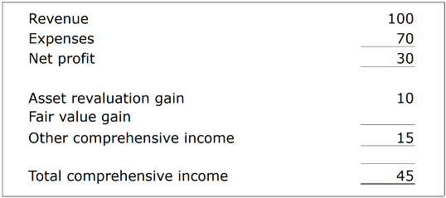

# Statement of Changes in Equity

|  |  |  |  |  |  |  |
| --- | --- | --- | --- | --- | --- | --- |
|  | Share capital | Asset revaluation reserve | Fair value reserve | RE | Treasury shares | Total |
| Beginning balance |  |  |  |  |  |  |
| Net profit |  |  |  | X |  |  |
| Other comprehensive income |  | X | X |  |  |  |
| New shares issued | X |  |  |  |  |  |
| - Treasury shares acquired |  |  |  |  | (x) |  |
| - Dividend |  |  |  | (x) |  |  |
| Ending balance |  |  |  |  |  |  |

# Cash Flow Statement

Importance

* Cash: Includes both cash and cash equivalents
* Purpose: to see how a company obtains and spends its cash
* Through: analysis of comparative balance sheet + income statement + additional info

Operating activities

* Principal revenue-producing activities of the entity
* Reports all current assets and current liabilities except:
  + Short term investments, short term notes receivables (I)
  + Short term notes payable, the current portion of long term debt (F)

Investing activities

* Acquiring and disposing long term assets
* PPE, investments, loans (lending and collecting from others)

Financial activities

* Activities that change the size or composition of contributed equity
* Issuing shares, dividend, notes (borrowing and repaying), bonds, treasury shares

Direct method

* Lists cash receipts and payments (from revenue/expense account + the beginning and ending balances of the account receivable/payable)

|  |  |  |
| --- | --- | --- |
| Cash flows from operating activities  Cash receipts:  …  Total cash receipts  Less cash payments:  …  Total cash payments  Net cash from operating activities | X  (Y) | $X  (Y)  Z |

Indirect method

*Operating cash flows*

* Reports profit before tax, adjusts profit amounts for necessary items
* Adjustments:

1. Add back depreciation/amortization because they do not affect cash
2. Subtract gains or add back losses on sale of assets
3. Eliminate interest and dividend (dividend might be in operating; but default put in F)
4. Subtract/add changes in current assets/liabilities (except cash, special disclosure items)
   * 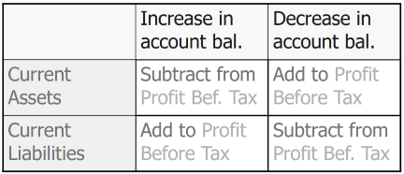General rule:

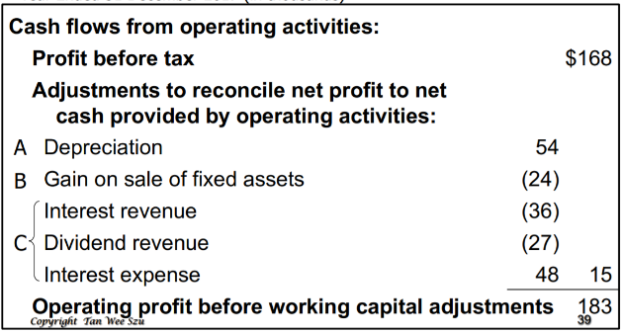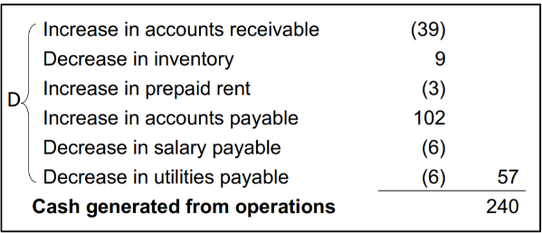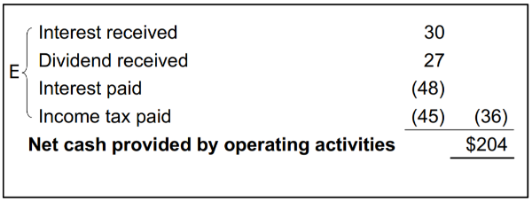

1. List related receipt/payment in CFS (from 3)

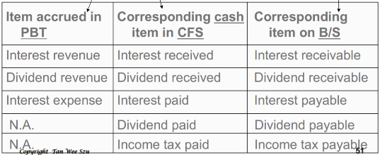

*Investing cash flows*

* PPE, investments, loans and other non-current assets (eg long term receivables)

*Financing cash flows*

* Short-term debt, long-term debt, paid-up capital

# Financial Analysis

Horizontal analysis

* Comparison over time
* For each account in the financial statements
  + Compute % change = x 100%
* Trend analysis (a form of horizontal analysis)
  + Trend % =

Vertical analysis

* Comparison over time
* Analyze changes in an account relative to a parameter
  + Income statement: gross sales/revenue
  + Balance sheet: total assets
  + Cash flow statement: total cash and equivalents
* Financial statements that included detailed vertical analysis are known as common-size financial statements (report the common-size %)

Ratio analysis

* Measures liquidity, solvency, efficiency, profitability and value of investment
* Liquidity
  + Current ratio =
    - Measures the ability to pay current liabilities with current assets
  + Acid-test/Quick ratio =
    - Measures sufficiency of liquid assets to pay current liabilities (cash, short term investments, net accounts receivable)
* Solvency
  + Debt ratio =
    - Overall ability to pay company’s debts
  + Times-interest-earned ratio =
    - No. of times income earned can cover interest expense (ability to pay interest)
* Efficiency (Collecting accounts receivable)
  + Accounts Receivable turnover =
    - Measures how fast AR is being collected
  + *Days’ sales uncollected* =
    - Measures how much AR there is at year-end
    - Also measures how many days it takes to collect AR
  + Inventory turnover =
    - No. of times average inventory was sold during that period
  + *Days’ sales in inventory* = x 365
    - How much inventory there is at year end, and how many days it takes to sell inventory
  + *Days’ purchases in accounts payable* = x 365
    - Measures how much AP there is at year-end
    - Also measures how many days it takes to pay AP
  + *Cash conversion cycle (CCC) = no. of days cash is tied up in operations*
  + Total assets turnover =
    - Ability to use assets to generate sales
* Profitability
  + Gross profit margin =
  + Net profit margin =
  + Return on assets =
    - Ability to generate profits from assets used
  + Return on equity =
    - Profits earned from ordinary shareholders’ equity
    - Return on equity = Net profit margin x asset turnover x financial leverage
    - =
      * DuPont analysis
      * Allows for analysis of the drivers of ROE
  + Basic earnings per share =
* Value of investment
  + Price earnings ratio =
    - Investors’ valuation of company’s prospects
  + Dividend yield =
    - Percentage of market value of company’s shares that is returned to shareholders as dividend each year

Net assets = total assets – liabilities

gross sales = net sales + sale allowances + discounts + returns